TABLE OF CONTENT

1. | Project Definition (Purpose, Scope, Identification of Need)
2. | Functional and Non-Functional Requirements
3. | User Characteristics
4. | Use case diagram
5. | Activity diagram
6. | Data Dictionary
7. | Template Integration
8. | Login and Registration with State Management

- Introduction
Based on the document and the initial requirements here is a comprehensive project definition:
1.1 Project Overview:-
The Community Management System aims to develop an innovative and efficient online platform for managing various activities and services within the community. The system will digitize management processes, making it easier for committee Major, Committee Members, and Members to collaborate and manage services such as Manage announcement like Events and Scholarships, Manage Donation and Hall booking.

  - Project Purpose:-
The Purpose of the Community Management System is to manage and coordinate various activities and services offered by the community.

  - Project Scope:-
The scope of the Community Management system is within the particular state(Gujarat).

  - Identification of needs:-
Previously all the datas were in physical form(on paper). Which makes it difficult to maintain and manage for longer period. As it can be lost or could tear off . So community management System will help to digitalize such data and to preserve it for decades.

- System Specific Requirement:-
2.1. Functional Requirement:-
Functional requirements define the Fundamental action that the system must perform.

Module 1: Manage User:
FRN | DESCRIPTION | Page
FR1 | This module will Provide the Following facility to Member:  - Register | Registration
FR2 | This module will Provide the Following facility to Users:  - Forget Password  - Login  - Change Password | sendotp  Login  Handle_recovery
FR3 | This module will provide the Following facility to the admin:  - Add Committee major  - Active/De-active Committee major | Manage_committee_major
FR4 | This module will Provide the Following facility to Member:  - Request for committee member | committee_member_request
FR5 | This module will Provide the Following facility to committee major:  - Approve/decline commiittee Member request | committee_member_request

Module 2: Manage announcement type:
FRN | DESCRIPTION | Page
FR1 | This module will Provide the Following facility to the Committee major:  - Create announcement type.  - Modify announcement type.  - Delete announcement type. | Manage_announcement_type
FR2 | This module will Provide the Following facility to the Committee major/committee member/ Members:  - View announcement type. | announcement

Module 3: Manage announcement:
FRN | DESCRIPTION | Page
FR1 | This module will Provide the Following facility to the Committee major/committee member:  - Create announcement  - Modify announcement.  - Delete announcement. | Manage_announcement
FR2 | This module will Provide the Following facility to the Committee major/committee member/ Members:  - Register for particular announcement  - View announcement | announcement

FRN | DESCRIPTION | Page
FR1 | This module will provide the Following facility to the Members:  - Give donation | donation
FR2 | This module will provide the Following facility to the committee member/committee major/member:  - View Donation. | View_Donation
Module 4: Manage Donation:

Module 5: Manage Hall
FRN | DESCRIPTION | Page
FR1 | This module will provide the Following facility to the Committee Members/committee major:  - Add Hall .  - Update Hall  - Active/deactive hall | Manage_Hall
FR2 | This module will provide the following facilities to Committee Member/Committee major/member:  - View hall | View_Hall

Module 6: Manage Hall Booking
FRN | DESCRIPTION | Page
FR1 | This module will provide the Following facility to the Member:  - Book Hall .  - Update Hall booking  - Delete hall booking | Manage_Hall_booking
FR2 | This module will provide the following facilities to Committee Member/Committee major/member:  - View hall booking | View_Hall_booking
FR3 | This module will provide the following facilities to Committee Member/Committee major:  - Approve/decline hall booking | View_hall_booking

Module 7: Manage Profile
FRN | DESCRIPTION | Page
FR1 | This module will provide the Following facility to the Committee Major/Member/Committee Member:  - Add details  - Update details  - Delete details  - View details | Manage_Profile

Module 8: Manage Payment
FRN | DESCRIPTION | Page
FR1 | This module will provide the Following facility to the Member:  - Make payment  - View payment | Manage_hall_booking
FR2 | This module will provide the Following facility to the committee Member/committee Major:  - View payment | Manage_hall_booking

  - Non-Functional Requirement:-
NFRN | DESCRIPTION | COMMENTS
NFR1 | The system will be using Password-Protected. Users will have to enter an ID/Password to access the application and we also use md5 for the authenticated. | Security
NFR2 | The system will be accessed 24*7 with a proper internet connection. | Availability
NFR3 | The application will be user-friendly and easy to operate. The functions will be easily understandable effective design and easy navigation. | Usability
NFR4 | The application can be easily tested by providing various inputs to check the models. | Testability

- User Characteristics:-

Admin
    - Add committee Major.
    - Active/De-active Major.

Committee Major
- Approve/Decline Committee Member request
- Create, Modify, View and Delete announcement type.
- Create, Modify , View and Delete announcements
- Register for Announcement.
- View Donation.
- Add, Update ,View and active/de-active Hall.
- Approve/Decline and View Hall Booking.
- Manage Profile.
- view payment.

Committee Member:-
- Create, Modify , View and Delete announcements
- Register for Announcement.
- View Donation.
- Add, Update and active/de-active Hall.
- Approve/Decline , View Hall Booking.
- Manage Profile.
- view Payment.

Member:-
  - Register themself.
  - Request to Committee Memebr.
  - Give Donation.
  - view Donation.
  - Book the hall and update and delete it.
  - View Hall Booking.
  - Manage Profile.
  - Make and view Payment.

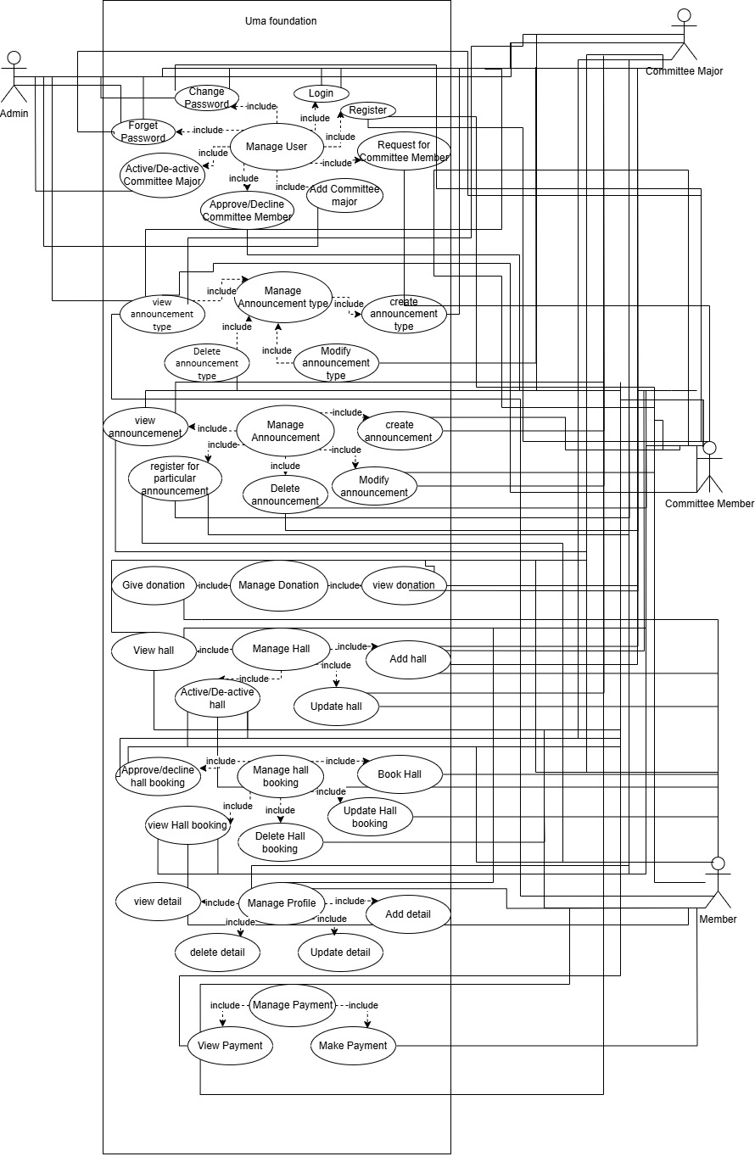

- Data Dictionary:-
Sr. No. | Field name | Data type | Size | Constraints | Description
1 | U_Id | Int | - | Primary key | Uniquely Identifies the committee member
2 | Name | varchar | 10 | Not null | Defines the name
3 | Username | varchar | 10 | Not null
4 | Gender | Char | - | Not null | Defines the gender
5 | Dob | Date | - | Not null | Defines the date of birth
6 | c_ no | Bigint | 10 | Not null | Defines the contact no
7 | Address | Varchar | 30 | Not null | Defines the address
8 | Email | Varchar | 20 | Not null | Defines the Email
9 | Password | Varchar | 15 | Not null | Defines the Password
10 | Caste_ certificate | Varchar | 255 | Not null | Defines the Caste certificate
11 | Status | Bit | - | Not null | Defines the member status is active or not
12 | role | varchar | 10 | Not Null | Defines the role of the user
Table Name: User

Table Name: Announcement Type
Sr. No | Field name | Data type | Size | Constraints | Description
1 | at_ id | Int | - | Primary key | Uniquely Identifies the Event
2 | at_ name | Varchar | 20 | Not null | Defines the name of the Event
3 | Status | Bit | - | Not null | Defines whether the status is active or not

Table Name: Announcement
Sr. No | Field name | Data type |  | Size | Constraints | Description
1 | a_ id | Int |  | - | Primary key | Uniquely Identifies the Event
2 | a_ title | Varchar |  | 20 | Not null | Defines the name of the Event
3 | Status | Bit |  | - | Not null | Defines whether the status is active or not
4 | at_id | int |  | - | Foreign key
5 | description | varchar |  | 20 | Not null
6 | Declaration_date | date |  | -
7 | From_date | date
8 | To_date | date
9 | Participation_form |  | varchar | 255

Table Name: Announcement participation
Sr. No | Field name | Data type | Size | Constraints | Description
1 | ap_ id | Int | - | Primary key | Uniquely Identifies the Event
2 | a_ id | int | - | Not null | Defines the name of the Event
3 | U_id | int | - | Not null | Defines whether the status is active or not
4 | Participation_form | varchar | 255 | Foreign key
5 | Submittion_date | date | -

Table Name: Hall_ master
Sr. No. | Field name | Data type | Size | Constraints | Description
1 | Hall_ id | int | - | Primary key | Uniquely Identifies the Hall booking master
2 | Name | Varchar | 20 | Not null | Defines the name of the Hall booking master
3 | Capacity | Int | - | Not null | Defines the capacity of the Hall booking master
4 | Image | Varchar | 255 | Not null | Define the image of the hall booking master
5 | Address | Varchar | - | Not null | Define the Address of the hall booking master
6 | Rent | varchar | 20
7 | Status | varchar | 20

Table Name: Hall _booking
Sr. No | Field name | Data type | Size | Constraints | Description
1 | H_ id | Int | - | Primary key | Uniquely Identifies the Hall booking
2 | U_ Id | int | - | Foreign key | Defines the type of complaint Referenced from Tbl_User(U_id )
3 | Hall_ id | Int | - | Foreign key | Defines the type of Hall booking Referenced from Tbl_hall_booking_master(Hall_id )
4 | Request_status | bit | - | Not null | Defines whether the status is active or not
5 | Start_Date_Time | DateTime | - | Not null | Defines the start time of the Hall Booking
6 | End_ Date_Time | DateTime | - | Not null | Defines the End time of the Hall Booking
7 | Request_date | date | -
8 | Transaction_id | varchar | 20
9 | Payment_date | date | -

Table Name: Donation
Sr. No | Field name | Data type | Size | Constraints | Description
1 | D_ id | Int | - | Primary key | Uniquely Identifies the Donation
2 | Amount | Float | - | Not null | Defines the Amount for Donation
3 | Date | Date | - | Not null | Defines the Date for Donation
4 | Status | varchar | 255 | Not null | Defines whether the status is active or not
5 | U_Id | int | - | Foreign Key | Defines the type of user Referenced from Tbl_User(U_id )
6 | Transaction_id | Varchar | - | Not null

Table Name: Scholarship
Sr. No | Field name | Data type | Size | Constraints | Description
1 | S_ id | Int | - | Primary Key | Uniquely Identifies the Scholarship id
2 | U_ Id | Int | - | Foreign Key | Defines the type of complaint Referenced from Tbl_User(U_id
3 | a_id | int | -
4 | Adhar_ card _image | varchar | - | Not null | Define the Adhar card no
5 | status | Varchar | - | Not null | Defines whether the status is active or not
6 | School/university name | Varchar | 30 | Not null | Define the School/College Name
7 | Previous_year_marksheet | Float | - | Not null | Define the SSC Marksheet
8 | Current_year_std | Varchar | 30 | Not null | Define the Course Name
9 | Pan_card_no_father | varchar | 11 | Not null | Define the Pan Card of Father
10 | Pan_card_no_mother | Varchar | 11 | Not null | Define the Pan card of Mother
11 | Occupation_father | Varchar | 20 | Not null | Define the Occupation of Father
12 | Occupation_mother | Varchar | 20 | Not null | Define the Occupation of Mother
13 | Father_income | Float | - | Not null | Define the Father's Income
14 | Mother_income | Float | - | Not null | Define the Mother's Income
15 | Bank_name | Varchar | 30 | Not null | Define the Bank Name
16 | Bank_IFSC_code | Varchar | 11 | Not null | Define the Bank IFSC code
17 | Account_no | Big int | - | Not null | Define the Account no
18 | Income_certificate | Varchar | 255 | Not null | Define the Income certificate
19 | Fees_receipt | Varchar | 255 | Not null | Define the Fees receipt

